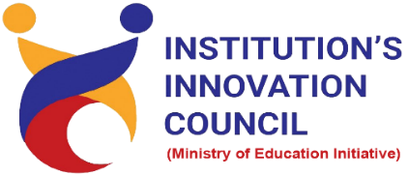
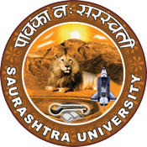

Celebration of 75 Years of Independence -Azadi Ka Amrit Mahotsav

12 August 2022
At
Seminar hall, Department of Pharmacy
Saurashtra University Campus, Rajkot
Contents

Saurashtra University – IIC 2
Event Registration Link 2
Brief about Event 3
Outcome 3
Connect Us: 5

Saurashtra University – IIC
The university is dedicated to instruction, research, and extending knowledge to the public (public service). Ministry of Education (MoE), Govt. of India has established ‘MoE’s Innovation Cell (MIC)’ to systematically foster the culture of Innovation among all Higher Education Institutions (HEIs). The primary mandate of MIC is to encourage, inspire and nurture young students by supporting them to work with new ideas and transform them into prototypes while they are informative years. Saurashtra University is one the Organization that have constituted the IIC to foster the vision of MoE and be a part for the promotion and development of innovation ecosystem.

Event Registration Link

bit.ly/SUSEC-AMT

Brief about Event

We had celebrated 75 Years of Independence -Azadi Ka Amrit Mahotsav- 12 August 2022 to spared awareness about conserving Independence by organizing a session on "Essay writing competition on freedom fighters". Students and Faculty of Saurashtra University participated and celebrated 75 Years of Independence -Azadi Ka Amrit Mahotsav.

The objective of the competition was to encourages the student to enhance their thinking and writing skills. The session was focus on the role of our freedom fighter to get a freedom and become independent. Student put their best effort to write essay. The winners of the competition were given prizes. This was an exclusive competition for raise student ability, awareness to take positive action for protect our country.
The aim behind organizing this program was to give awareness to student about our freedom fighters. For this purpose, we had celebrated 75 Years of Independence -Azadi Ka Amrit Mahotsav.

Outcome

As per the event, today’s Independent India was the aim of every freedom fighter were understood. Students learn a lot about importance of Independence Day and struggle of our freedom fighters. Students also understood why we celebrated 75 Years of Independence -Azadi Ka Amrit Mahotsav. This was an exclusive event.

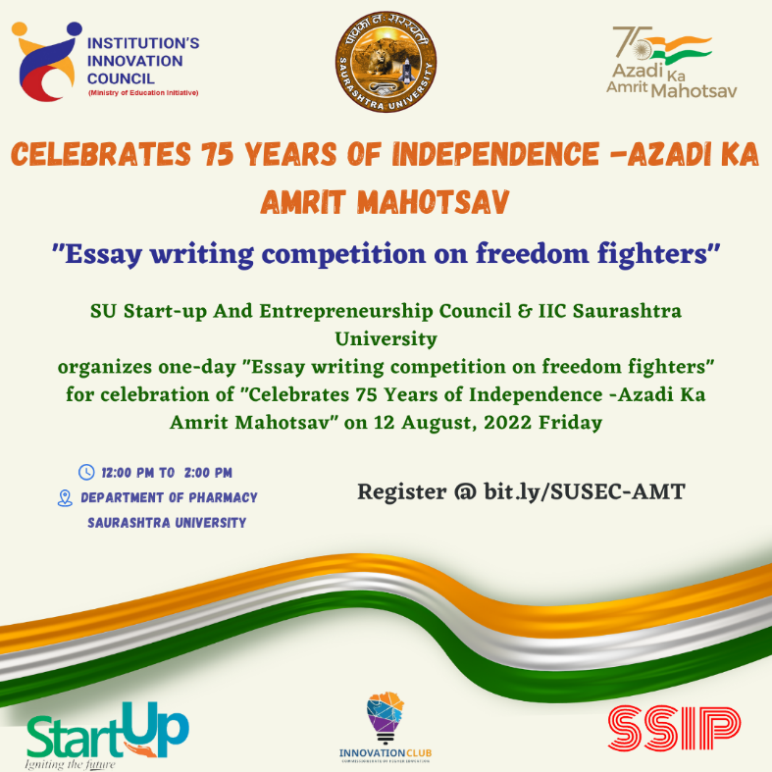

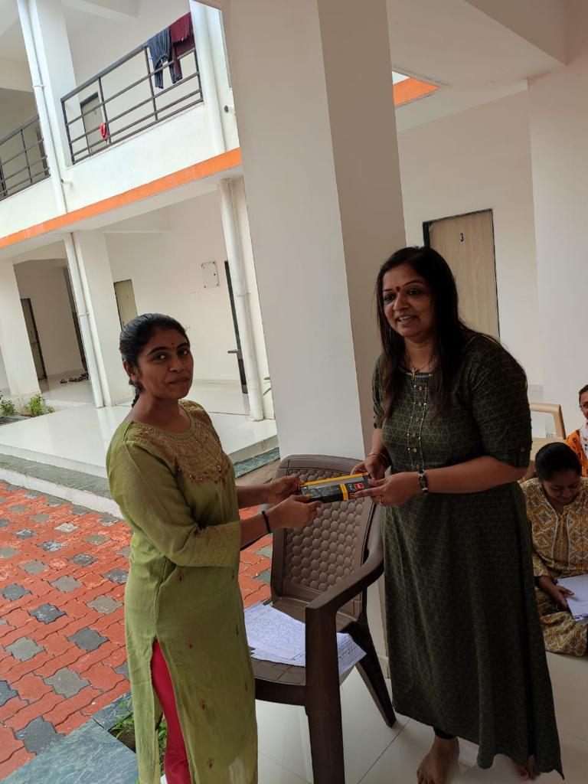
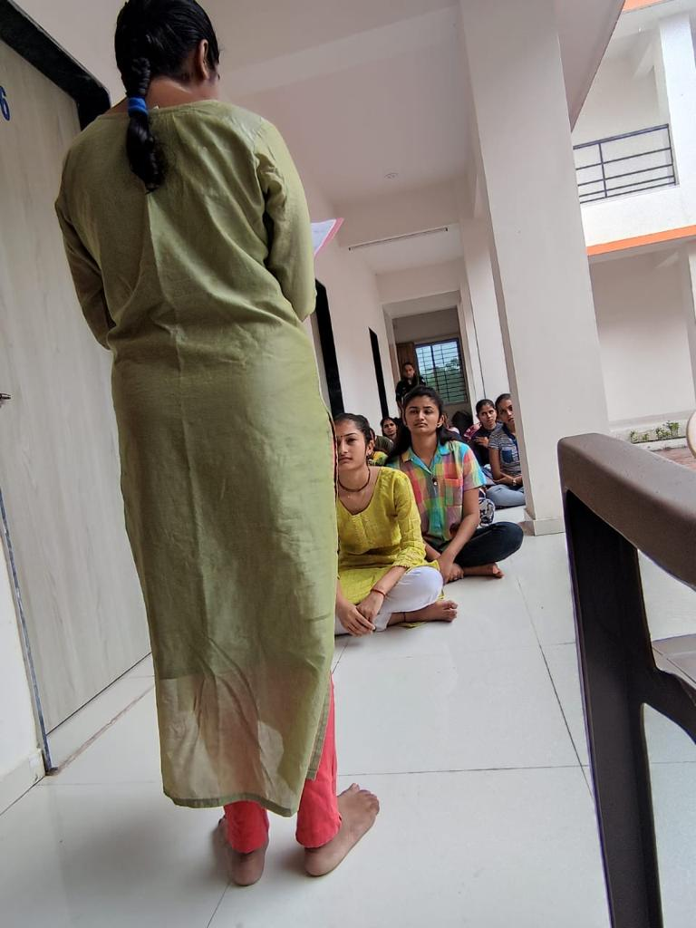

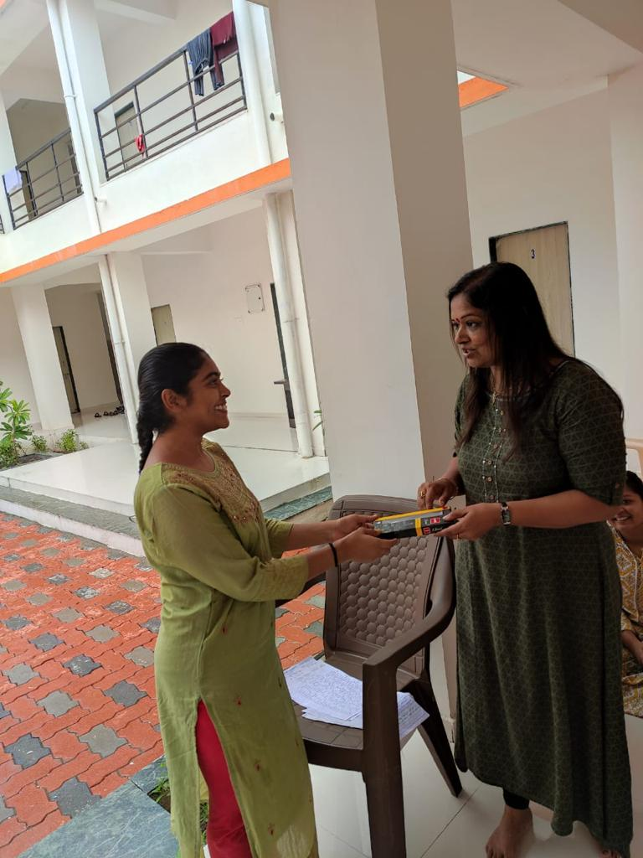

Connect Us:

https://www.linkedin.com/company/susec iic@sauuni.ac.in
https://www.facebook.com/iicsauuni bit.ly/SU-SSIP Location
https://www.instagram.com/susecrajkot https://bit.ly/SUSEC-youtube

